Entering time into timesheets

- go to www.bcfsolutions.net
- click on Employees Only link to open EMPLOYEES ONLY page
User Name: BCF (all caps)
Password: Solutions (case sensitive)
Click Enter Employee Area button to open the EMPLOYEES ONLY page with options.

- Click Timesheet bullet to open Deltek Time & Expense page

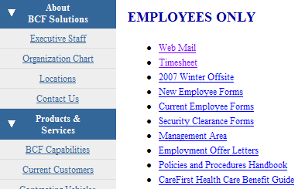

http://38.119.107.58/DeltekTC/welcome.msv

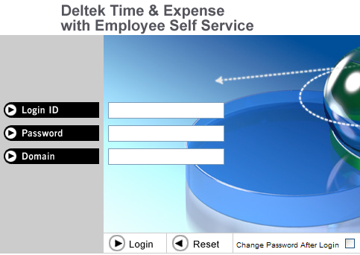

- Enter the following information

Login ID will be your employee ID number
Password will be your individual Social Security number with dashes
Ex: 000-00-0000
Domain will be BCF (All caps)

Click the Login button to log yourself in.

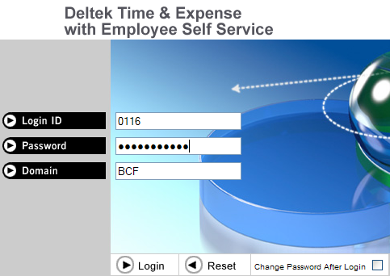

5) Once logged in you will be asked to change your password. Enter a new password and click the OK button to accept new password. PLEASE NOTE TO SELECT A PASSWORD THAT WILL BE EASILY REMEMBERED BY YOU ONLY

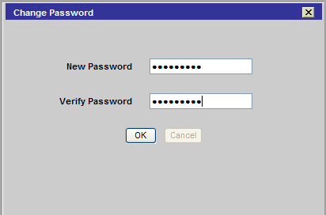

- Click Timesheet button to top left of screen to open your individual Timesheet page

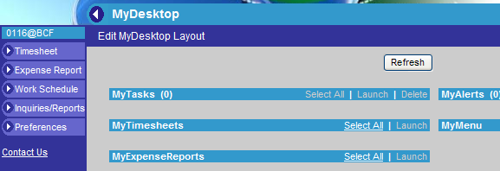

- Enter number of hours per day you’ve worked in corresponding date.

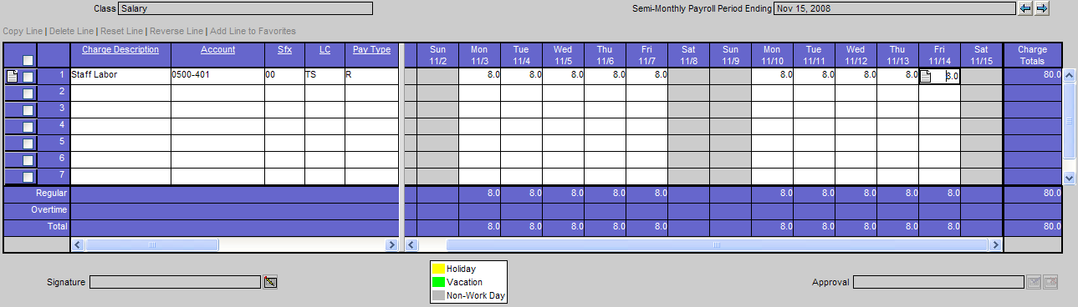

7) When you’re done filling out your timesheet click the Signature button to sign your timesheet.

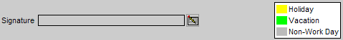

8) You will then be prompted to certify that your hours correct by reentering your password.
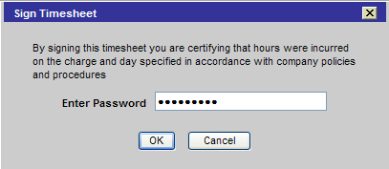

9) When you’ve hit the OK button you’ll need to log off by click the log out button located to the top right.

